Task1

Name – Tejas Jambhale

Reg No. – 17BCE0861

When Obama is searched in the frequency attribute, we can see that it has been mentioned a total of 70287 times which is a large number for a personality even Donald Trump has 58191



As we can see from below table, Obama popularity peaked during 2005-2009 and 2010-2014 when he was the president. Previously there were hardly any mentions

On the other side he is most often mentioned in spoken news channels and newspaper being a political figure and rarely in fiction or academic sources

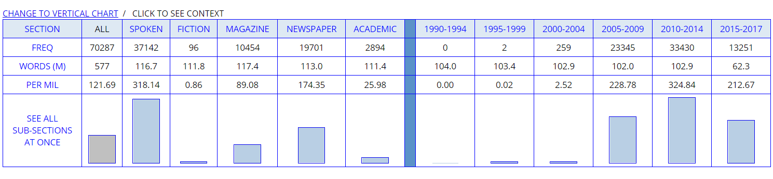

**Rules of COCA -**

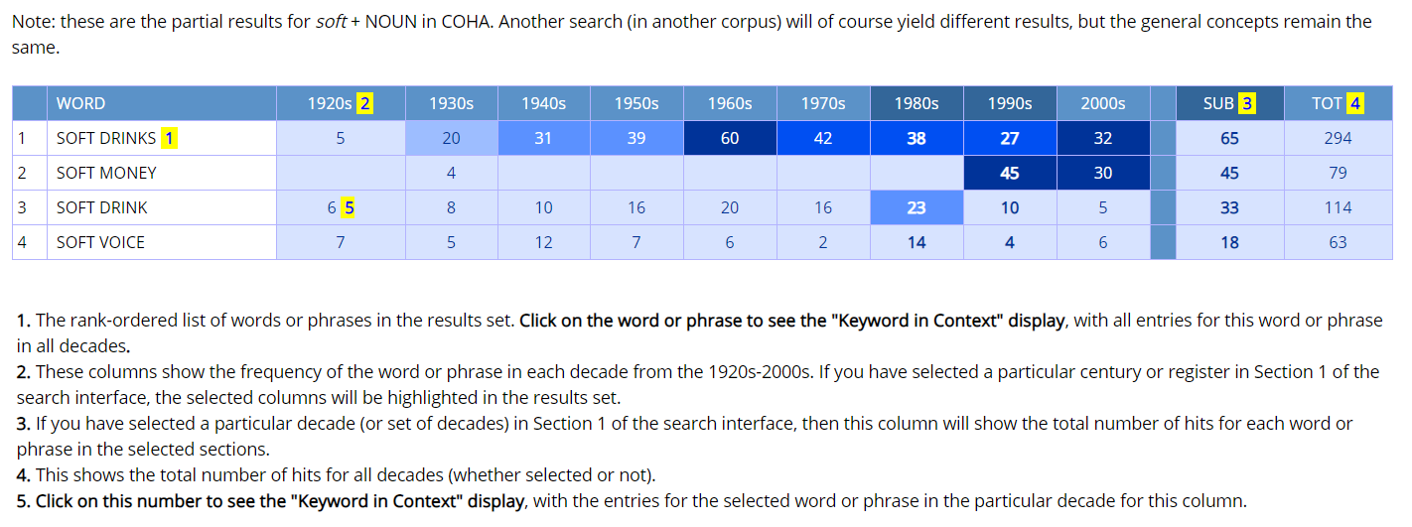

**Some places where Obama has been found -**

